**Homework #2 Instructions**

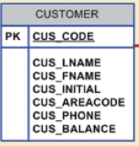

Please do the following:

* Create a blank Word document and write your full name at the top.
* Log into your Oracle *liveSQL* account. Upload the ***saleco.sql*** database script if you did not already do so. Run the script to create all saleco hardware store database tables.

**Query 1:** Write an SQL statement to insert one record in the CUSTOMER table such that customer first and last names are your own first and last names. Area code should be one of these: 615, 713, or 931. All of the other data for this record should be fictitious. Run this SQL statement and generate an output saying one row inserted.  
  
Create a single screenshot of the SQL statement and its output; make sure your account is visible in the same screenshot (an example below). Paste the screenshot in the Word document that you created above.

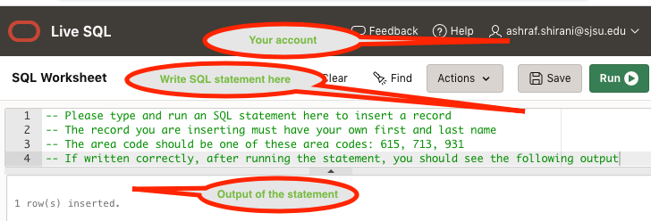

**Query 2:** Write an SQL statement to show all customers whose last name and first name is the same as your own last and first names. Run this SQL statement and generate an output. Create a single screenshot of the SQL statement and its output; make sure your account is visible in the same screenshot (an example below). Paste the screenshot in the Word document below Query 1 screenshot.

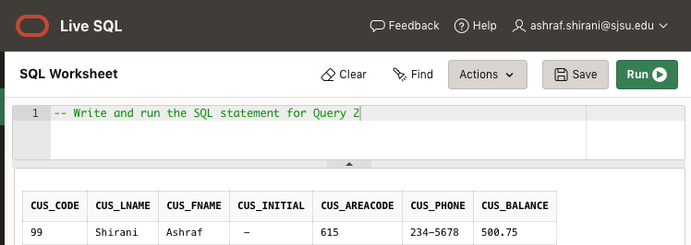

What to submit:

Please upload to Canvas the Word document as described above. The Word document should contain your full name at the top, and screenshots of the above two queries. Each screenshot should include the following three items: (1) complete SQL statement, (2) complete output of the statement, (3) your email account.